PARTICIPATION PLANNING
Effective participation planning for sustainable success

Table of contents
Introduction 3
Features of effective participation planning 3
Using the drivers of participation in planning 4
How to use the planning process and resources 5
As a step-by-step planning process ​ 5
To inspire a new way of thinking 5
To assist in reviewing your participation plan 5
The planning process 5
Principles 6
Step 1: Who are we? 7
Step 2: Where are we now and where do we want to be? 7
Step 3: How do we get there? 8
Step 4: What do we need to get there? 8
Step 5: How do we know if we are on track? 9
Learn more 9
Appendix 1 10
Participation plan template 10
Appendix 2 11
Stakeholder map 11
Appendix 3 12
Stakeholder engagement plan 12
Appendix 4 13
SWOT analysis by drivers of participation 13
Appendix 5 14
Gap analysis by drivers of participation 14

Introduction
Sport Australia is committed to helping sports deliver clear aligned strategy and direction across all levels of the sport. We encourage national sporting organisations to develop unified and inclusive strategies in partnership with their key stakeholders that set the direction at all levels of the system.
Participation planning is the operational tool for bringing the aligned strategy to life. Start by building a strong planning foundation and carry it through the duration of the planning process to create a quality plan. It's also important to engage stakeholders in the planning process to shift the sport to the desired state.

Features of effective participation planning
"Someone’s sitting in the shade today because someone
planted a tree a long time ago".
Warren Buffett

A national participation plan is a road map to help you to deliver on your sport's strategic plan, by agreeing on your participation objectives and an agreed set of actions. It also ensures you consider resourcing and how to measure success. Effective participation planning for sustainable success requires:
- clear leadership
- a well-articulated purpose and vision for your sport
- engagement of relevant people throughout the process
- early and frequent consultation with partners and stakeholders to facilitate buy-in
- the ability to respond to new evidence including the need for change
- the ability to prioritise resources to achieve critical objectives
- clear performance measures related to participation objectives
- ongoing, planned, formal and informal monitoring and review
- periodic independent monitoring and evaluation of progress and performance.

Using the drivers of participation in planning
Sport Australia has co-designed a set of nine drivers of participation, which are the factors identified by stakeholders as having the most significant influence on driving positive participation outcomes. The drivers are as follows and more detailed information can be found at drivers of participation.

Market insights  Ensuring that all decisions are based on data and evidence about the market – your consumers and competitors. This is the most important driver to overcome barriers to participation. |  | Product design  Developing products with benefits and features to meet consumer needs and wants. |  | Workforce  How products are delivered to the market.
Marketing and Communication  Messaging and methods used to communicate internally and to consumers. |  | Infrastructure and equipment  Providing appropriate, accessible and affordable infrastructure and equipment. |  | Commercial  Developing sustainable participation products and commercialising related assets.
Governance  A strong governance structure, committed to achieving participation outcomes. |  | Unified behaviours  A whole-of-sport approach to participation. |  | Management  The experience, expertise and performance of the management team.

How to use the planning process and resources

As a step-by-step planning process ​
Use the planning process and resources to step through the development of a participation plan. Start by establishing a national planning team. Use the stakeholder map and engagement plan tools to identify and detail ways to engage key partners, the SWOT and gap analysis to reflect and consider how you can achieve your participation objectives, and the participation plan template to bring your outputs and plan together.

To inspire a new way of thinking
When updating your organisation’s participation plan, use the information and resources to change the way planning has been conducted in the past. The SWOT by drivers of participation will help identify new opportunities and the gap analysis by drivers of participation is a great tool to facilitate a group discussion about priorities for your sport and challenge the status quo.

To assist in reviewing your participation plan
Often sports have 4-year rolling participation plans and undertake annual or regular reviews. Use the planning process and the drivers of participation as a framework for review and to identify if adding new areas to the plan would enhance participation outcomes.

The planning process
This planning process reflects the unique considerations of sporting organisations and the environment they operate in. The principles set the tone for the behaviours and actions and the steps are based on key questions to consider when creating a participation plan.
Organisations have different planning needs and can use the step by step planning process to develop a comprehensive participation plan or focus in on specific steps or resources to enhance their plan.
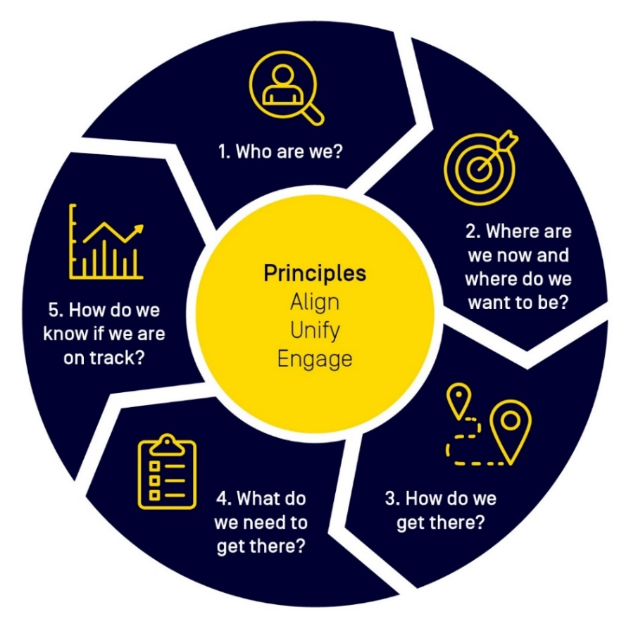

Principles

Align
Participation planning should strongly align with your whole-of-sport national strategic plan. Make sure you have a good understanding of your sport’s participation related strategic priorities before you start the participation planning process. Regularly revisit your strategic priorities to ensure plans continue to align.
A participation plan should:
- cascade from a national strategic plan
- be consistent in its ambition, focus, look and feel
- be co-designed by key stakeholders then tailored for local adoption
- be fully supported and resourced by boards, management, participation teams and the community
- anchor key decision making for the duration of the plan.

Unify
Unified behaviours are an enabling driver of participation and should be implemented to create a whole-of-sport approach to participation. Collaboration around a planning process and consensus on where a sport is heading and what it is trying to achieve has many benefits and builds mutual trust.

Tips
- Establish a nationally agreed team of individuals from different levels of your organisation and stakeholder representatives that have a complementary skill set who will be responsible for driving the planning process. An identified lead, timelines and governance should also be established.
- This team, or similar, should continue past the development of a plan and assist to implement, monitor and evaluate your sports progress on an ongoing basis.

Engage
Successful participation planning and implementation is impacted by a wide range of stakeholders. Don't underestimate the importance of meaningful, early and ongoing engagement to ensure your participation plan has the best chance of sustainable success.

Tips
- Consider the impact of both internal and external stakeholders.
- Create a Stakeholder map to understand relationships and the impact stakeholders can have on the success of your plan.
- Involve your stakeholders through the decision-making process to create buy-in. Use the Stakeholder engagement plan template to plan and track engagement.
- Value the unique insights into issues, challenges and opportunities that your stakeholders bring. Understand that at times stakeholder consultation can be challenging but is extremely beneficial for effective planning.
- Get creative with your engagement. Use online surveys, file-sharing platforms, workshopping activities etc. You can find cost-effective methods for collecting stakeholder views and engaging them in the process.
- Commit to genuine engagement and co-design. Don't circulate draft plans before commencing the engagement process as it undermines the process and trust.

Step 1: Who are we?
What is your whole of sport purpose and vision and what are your values?

Considerations
- Who does your sport primarily exist to benefit and what benefit do they expect?
- What attitudes and behaviours do you require to make the vision a reality?
- How can you align your participation planning with your sports strategic plan, purpose, vision and values?

Resources
- Desktop review: Gather and analyse information on your sports purpose, vision, values and strategic priorities. This is an important step in understanding the context for your participation planning.
- Purpose, vision and value board: List each of these statements and brainstorm ways to bring each to life through your sport’s participation approach. Use a different colour to identify current and future ideas. The future ideas lead into step 2 of the planning process.
- Fishbowl activity: This activity will help ensure different opinions and viewpoints are heard and considered during group planning discussions.

Step 2: Where are we now and where do we want to be?
Use data, evidence and insights to understand your current state and desired state. What market insights do you have and who are your target markets?

Considerations
- What are your sports achievements and challenges in the past year or past four years?
- What is the current state of your sport internally and externally? Consider in the context of your sports agreed purpose:
  - Who are your customers?
  - What are their wants and needs?
  - What are the market trends?
  - Who are your competitors and how do you compare?
- How does your sports current state compare to the desired state? This will help form your participation objectives.
- Review thinking against Sport Australia's drivers of participation to ensure all factors have been considered.

Resources
- SWOT analysis by drivers of participation: SWOT analysis is a situational analysis technique you can use to identify your sport’s strengths and weaknesses, as well as its external opportunities and threats.
- Gap analysis by drivers of participation template: Gap analysis is a method of assessing the differences between current situation and desired performance.
- Participation plan template: Use this template to detail your participation objectives.
- Market trends: Key sport market and consumer trends impacting participation
- Participation across life stages: Sport and physical activity data and insights
- Inclusive Sport: Creating positive, inclusive experiences.
- Start, Stop and Continue: Use this method to reflect on recent experiences and decide things to change as your organisation moves forward.

Step 3: How do we get there?
Identify and prioritise actions that will help your sport achieve its participation objectives. This will be your roadmap to future success.

Considerations
- What is business as usual and what are key shifts for your sport to achieve the participation objectives?
- Now your sport has highlighted the key participation objectives to focus upon and has articulated the needs of participants, what actions is your sport going to undertake to achieve them?
- What actions have the greatest impact on successful outcomes?
- Consult with your stakeholders to identify any potential risks or issues that may impact achieving the objectives and actions.
- Review against Sport Australia's drivers of participation to ensure all factors have been considered.

Resources
- Participation plan template: Document the actions needed to achieve your objectives.
- Anchors and Engines: Identify the factors that make actions move faster and those holding them back. Discuss how can you take advantage of or overcome these factors.
- Impact vs Effort: On a matrix, plot tasks based on their impact and the effort needed to complete them. This will help to identify major projects, quick wins and thankless tasks. This may help to prioritise appropriately or eliminate low-impact activities.
- Agreed prioritisation: Identify your sport’s priorities through group decision making. Prioritisation increases project success rate, increases alignment and assists decision making processes throughout the duration of the plan.

Step 4: What do we need to get there?
Identify resources needed to take actions that will help your sport achieve the participation objectives.

Considerations
- What human, financial, physical and intellectual resources does your sport require to achieve its objectives?
- How will your sport prioritise its participation objectives? What objectives are critical, important or desirable and how can the variables (e.g. actions, resources or timing) be adjusted to achieve your participation objectives?
- Does your sport have enough of the right people, in the right environment with enough financial and other resources and systems to get the job done?
- Who must do what by when to accomplish and drive the participation objectives? What are their roles and responsibilities?
- Do you have support from your CEOs/Boards? Don't create an unattainable wish list.

Resources
- Participation plan template: Detail the resources needed, responsible people, timelines and priorities.
- Budgeting methods: To help manage your plan efficiently you will need to develop a budget and monitor progress against it.
- Estimating activity duration: To help understand the time required to complete individual activities, start by considering your resources e.g. people/budget and then use work breakdowns, past examples or expert judgement to best estimate activity duration and timelines.

Step 5: How do we know if we are on track?
Track progress of objectives through development of SMART performance measures.

Considerations
- What does success look like?
- Are your measures SMART?
  - Specific: Keep it simple and describe exactly what will be accomplished when each objective is achieved
  - Measurable: The KPI needs to be measurable so it can be determined when it has been achieved
  - Attainable: Expect to achieve the KPI, it should be realistic but provide some ‘stretch’ (challenge)
  - Relevant: The KPI must relate to specific objectives
  - Time bound: Each KPI must have an ‘achieve by’ date (deadline)
- What measure is appropriate to achieve your objectives?
  - Outcome measures: Impact the result
  - Quality measures: Demonstrate improvement (e.g. accuracy, responsiveness, reliability)
  - Efficiency measures: Measures of productivity (e.g. time taken or cost management)
  - Project measures: Progress against a deadline (e.g. percentage complete)
- How are you going to monitor and evaluate your sports progress on an ongoing basis?
- How will you communicate your sports progress to partners and stakeholders?

Resources
- Participation plan template: Use this template to detail performance measures against your objectives.
- After Action Review: Seek continuous improvement through this reflective exercise.
- Retrospect: Reflect on your experiences to improve results.

Learn more
If you are interested in working with Sport Australia on participation planning, email the Participation Design team at participation@sportaus.gov.au

Appendix 1

Participation plan template
A detailed plan template outlining what is needed to achieve the objectives of your participation plan and how you will measure performance.
Where do we want to be? | How do we get there? | What do we need to get there? |  |  |  | How do we know if we are on track?
Participation objectives  Desired state | Actions  Detailed description of key actions to achieve objective | Priority  Low, medium or high | Responsibility  Allocate position | Resources  Human, financial, physical, intellectual | Timelines  Due date | Performance measures  KPIs related to participation objectives
Insert participation objective 1 | Insert action 1.1  Insert action 1.2  Insert action 1.3  Insert action 1.4 |  |  |  |  | Insert KPI 1  Insert KPI 2
Learn more about participation design.

Appendix 2

Stakeholder map
Use the stakeholder map to better understand your relationship with stakeholders throughout the planning process. Plot each stakeholder on the grid below by assessing the influence and interest they could have on your participation objectives.
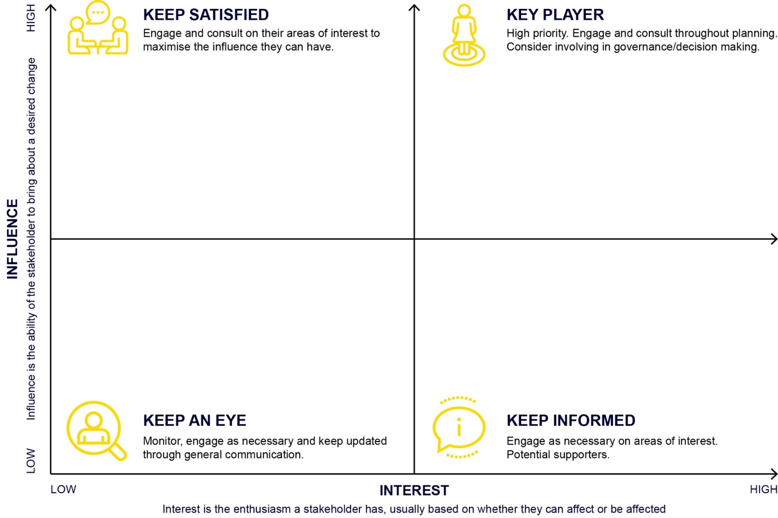
Insert name
Insert name
Copy and paste the circles below, type the name of your stakeholder inside and place it on the diagram to the left.

Internal stakeholder

External stakeholder
Learn more about participation design.

Appendix 3

Stakeholder engagement plan
After mapping your stakeholders, use this template to consider what is important to each stakeholder and how they like to be communicated with.
Stakeholder | What is important to them?  Key interests, issues and topics related to objectives | Engagement Type  Quadrant from stakeholder map | Engagement Details  Including communications, frequency and timing | Key Contacts | Tracking  Commentary
Learn more about participation design.

Appendix 4

SWOT analysis by drivers of participation
Consider your sport’s strengths, weaknesses, opportunities and threats (SWOT) in relation to each participation driver.
Drivers of participation | Strengths  Internal | Weaknesses  Internal | Opportunities  External | Threats  External
Market insights
Product design
Workforce
Marketing and communications
Infrastructure and equipment
Commercial
Unified behaviours
Management
Governance
Learn more about the drivers of participation and participation design.

Appendix 5

Gap analysis by drivers of participation
Compare your current state to your desired future state. Identify the gap and required actions to achieve the desired state. Consider each participation driver to ensure all factors have been considered.
Drivers of participation | Current state  Where are we now? | Desired state  Where do we want to be? | Actions (the gap)  How do we get there?
Market insights
Product design
Workforce
Marketing and communications
Infrastructure and equipment
Commercial
Unified behaviours
Management
Governance

Learn more about the drivers of participation and participation design.

