Risk Management

Risk Management Framework

Overview
The risk management framework (Fig.1) includes the following steps:
- consultation
- identifying the hazards
- assessing the risk
- identifying appropriate risk control measures
- implementing the control measures
- monitoring
- regular review

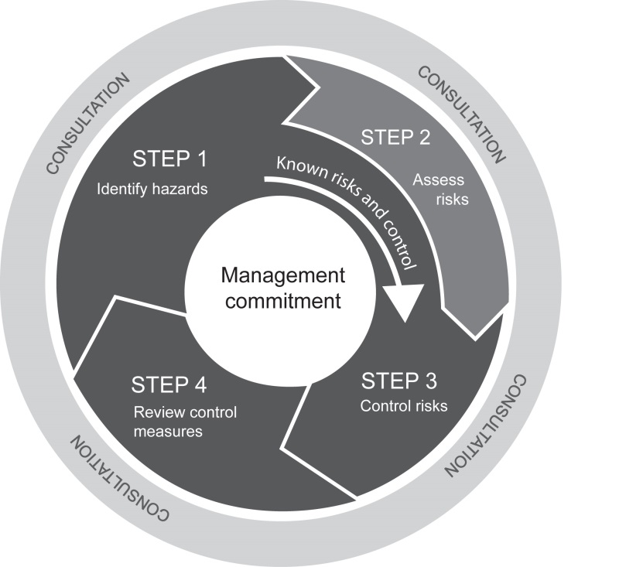
Fig. 1: From How to Manage Work Health and Safety Risks Code of Practice 2011
The tables and forms required for implementing this procedure are included in Part 3: Risk Assessment Procedures

Communication and Consultation
The WHS Act requires the ASC to consult, so far as is reasonably practicable, with workers of the ASC whose health and safety is, or is likely to be, directly affected from work conducted by the ASC. Adding to this, the ASC is required to consult, co-operate and co-ordinate activities with other business operators who are involved in the same activities or who operate at an ASC controlled facility.
Communication and consultation is required to take place during all stages of the risk management process. A consultative approach can:
- help establish the context appropriately
- ensure that all hazards are adequately identified
- bring different areas of expertise together for analysing risks, and
- enhance appropriate change management during the risk management process.

Identifying the Hazards
The identification of the risks to be managed is achieved by generating a comprehensive list of hazards that might compromise safety. Comprehensive identification is critical, because a risk not identified at this stage may be excluded from further analysis.
There are a number of methods by which hazards can be identified. These include:
- Consultation with staff and peers
- Work process evaluation - examine the manner in which tasks are performed to determine if they could they lead to increased risks
- Walk-through inspection
- Near-miss, incident, accident, injury and illness records and data
- Consultation with health and safety representatives, as well as specialist practitioners, representatives of industry associations etc
- Safety Data Sheets, Product Labels and manufacturers specifications

Examples of Common Hazards
Hazard | Potential harm
Manual tasks | Overexertion or repetitive movement can cause muscular strain
Gravity | Falling objects, falls, slips and trips of people can cause fractures, bruises, lacerations, dislocations, concussion, permanent injuries or death
Electricity | Potential ignition source.  Exposure to live electrical wires can cause shock, burns or death from electrocution
Machinery and equipment | Being hit by moving vehicles, or being caught by moving parts of machinery can cause fractures, bruises, lacerations, dislocations, permanent injuries or death
Hazardous chemicals | Chemicals (such as acids, hydrocarbons, heavy metals) and dusts (such as asbestos and silica) can cause respiratory illnesses, cancers or dermatitis
Extreme temperatures | Heat can cause burns, heat stroke or fatigue  Cold can cause hypothermia or frost bite
Noise | Exposure to loud noise can cause permanent hearing damage
Radiation | Ultra violet, welding arc flashes, micro waves and lasers can cause burns, cancer or blindness
Biological | Micro-organisms can cause hepatitis, legionnaires’  disease, Q fever, HIV/AIDS or allergies
Psychosocial hazards | Effects of work-related stress, bullying, violence and work-related fatigue
To assist with hazard identification refer to Attachment 2, Form A: Workplace Hazard Identification Checklist.

Hazard Inspections
Workplace hazard inspections are a systematic process of visually inspecting the workplace to identify hazards which require control measures to reduce the risk of injury.
Hazard Inspections are conducted using checklists to prompt the person(s) conducting the inspection to identify hazards. Workplace safety inspections are to seek input and involvement from personnel who are required to undertake the area or task being inspected.
The frequency of hazard inspections will vary depending on the risk level of the tasks, equipment and substances used.

Assessing the Risk
Risk assessment is the overall process of risk identification, risk analysis and risk evaluation. Risk assessment involves the determination of the potential effects of the hazard and how the hazard occurs. To determine the potential effects, it may be necessary to consult any or all of the following:
- Safety Data Sheet (SDS) for a substance
- the manufacturer
- relevant literature
- other like workplaces
- industry associations.

When a risk assessment is required
The identification of hazards and the assessment of associated risks must be undertaken:
- if it has not been done before
- when a hazard has been identified
- after an incident, accident or workplace illness
- at regularly scheduled times appropriate to the workplace
- before the introduction of any equipment or substance
- before the introduction of a new work practice or procedure, and
- before changing a workplace or a work practice, or an activity or process, where the change may give rise to a risk to health or safety.
- where the ASC provides services or goods to others e.g. a project where a health and safety requirement or risk has been identified.
A risk assessment must be completed for any high risk activities as stipulated within the WHS Act or Regulation. This includes but is not limited to entry into a confined space and live electrical work.

When a risk assessment may not be required
A risk assessment may not be necessary if:
- legislation requires that a hazard is to be controlled in a specific way
- guidance material, such as a code of practice, establishes a method of controlling a hazard that is applicable to work environment and a decision is made to adopt this method
- a decision is made to implement well known industry specific best practice controls which are suited to the circumstance.
The risk assessment process is to be completed using the risk assessment form at Attachment 3, Form B: Assessment and Control of WHS Risks.
Assessment of the risks occurs after the hazards for the activity, process, equipment etc have all been identified. Assessing risk is a two-step process requiring analysis of consequences and likelihood.

Consider the consequences
For each hazard or task/activity use the following table to rate the consequences associated with each of them by comparing with the possible consequences given in Table 1 below.
Table 1: Consequence
Rating | Consequence
Severe | Death or multiple life threatening injuries.
Major | Life threatening injury or multiple serious injuries causing hospitalisation.
Moderate | Serious injury causing hospitalisation.
Minor | Minor injury requiring medical treatment and / or lost time from the workplace.
Negligible | Ailments requiring first aid treatment - minor cuts, bruises, bumps.

Consider the likelihood
For each hazard or task/activity, use Table 2 to rate the likelihood of an incident that will lead to the consequences that you have determined. Consider all of the options for each rating and use the most likely rating that is possible for the defined consequences.
Remember that likelihood is related to exposure and exposure depends upon duration and frequency of exposure (or operation) as well as on the number of people exposed. For example, exposing eight people to a moving machinery hazard for one hour each is theoretically equivalent to exposing four people for two hours each.

Table 2: Likelihood
Likelihood | Description | Frequency
Almost certain | Expected to occur in most circumstances | Likely to occur more than once per year
Likely | Probably occur in most circumstances | Likely to occur approximately once per year
Possible | Could occur at sometime | Likely to occur approximately once every five years
Unlikely | Not expected to occur | Likely to occur approximately once every five to ten years
Rare | Exceptional circumstances only | Likely to occur with less frequency than once every ten years

Risk Level
A risk matrix can be used to plot the consequence against the likelihood and determine the level of risk associated with each hazard or task/activity. Table 3 below shows the level of risk associated with each combination of consequence and likelihood. The risk rating could be Very High, High, Moderate or Low.

Table 3: ASC’s Risk Matrix – Determination of Level of Risk
Likelihood | Consequence
 | Negligible | Minor | Moderate | Major | Severe
Almost certain | Low | Medium | High | Very High | Very High
Likely | Low | Medium | High | High | Very High
Possible | Low | Medium | Medium | High | High
Unlikely | Low | Low | Medium | Medium | High
Rare | Low | Low | Low | Medium | Medium
At the ASC, WHS risks can be placed in one of four categories: very high, high, medium or low as outlined below:
Very High | Dangerous level of risk which is unacceptable and required to be controlled immediately. Access and exposure to the hazard is to be restricted until the risk can be lowered to an acceptable level. A hazardous task must not be undertaken if rated as extreme until review and approval by the Manager
High | Unacceptable level of risk which must be controlled immediately. Control measures would involve eliminating, substituting, isolating or engineering out the source of the risk from the activity or equipment. The timeframe for the completion of at least one control to reduce the risk to low or negligible is within 24 hours. Hazardous tasks or activities rated as high require review and approval by Manager before being undertaken.
Medium | Unacceptable level of risk. The timeframe for the completion of risk controls to lower the risk to a low or negligible level is within 14 days.
Low | These risks are considered acceptable. Accordingly, no further action is necessary. However, if there are controls which can be initiated that are easy and inexpensive they can still be administered. The timeframe for the completion of controls associated with this level of risk is within 28 days.

Risk Control
The primary aim of risk control is to eliminate the risk by removing the hazard. When this is not possible the risk must be minimised using one or more of the options from the hierarchy of controls. The risk control measure selected must be the highest possible option in the hierarchy to minimise the risk to the lowest level that is reasonably practicable.
Step 1: Eliminate the risk by removing the hazard, e.g. removing a broken chair from the workplace.
Step 2: If elimination of the risk by removing the hazard is not reasonably practicable then the hierarchy of controls must be followed to minimise the risk:

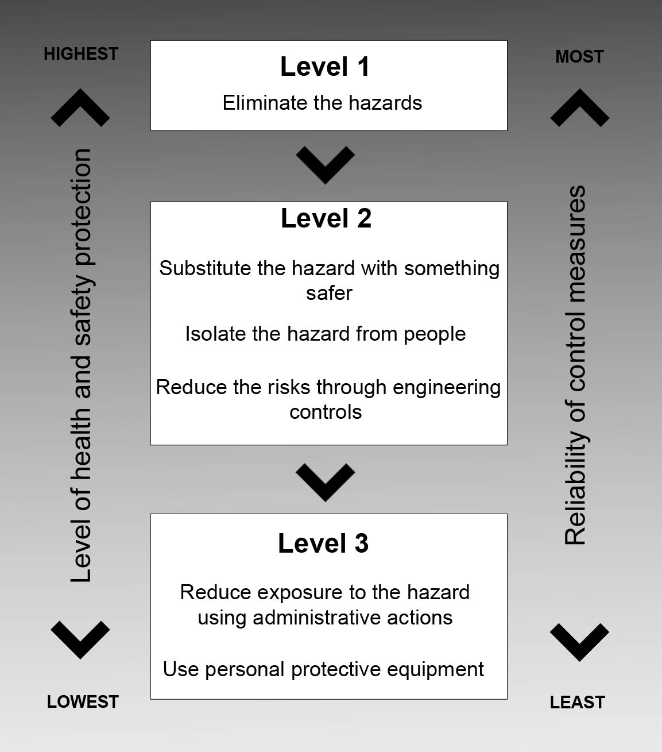
Fig. 2: From How to Manage Work Health and Safety Risks Code of Practice 2011
It is a mandatory requirement of the WHS legislation that risks should be controlled using the hierarchy of control:
Control | Example
Eliminate the hazard | Remove trip hazards on the floor of a corridor, disposing of unwanted chemicals, etc.
Substitute with something that is safer | Use smaller packages to reduce the weight of items that have to be manually handled, use a less toxic chemical, use scaffolding instead of ladders to reduce the risk of falls.
Isolate the hazard | Use sound proof barriers to reduce noise levels, use an enclosed spray booth for spray painting, use remote control systems to operate machinery, store chemicals in a fume cabinet.
Modify tools, equipment or systems of work (engineering controls) | Use trolleys or hoists to move heavy loads, place guards around moving parts of machinery or fit cut-out switches, install residual current devices (electrical safety switches).
Use administrative control measures | Use Safe Work Method Statements (SWMS)/Job Safety Analysis (JSA’s), permit-to-work systems for hazardous work, provide training and supervision, regular maintenance of machinery and equipment, limit exposure time by introducing job rotation.
Use personal protective equipment (PPE) | Gloves, hard hats, hearing and eye protection, safety harnesses, high visibility clothing.  PPE should be the last resort. PPE protects the worker’s body from hazards, eg It is the least reliable form of protection. In most cases, it should only be used in the short term until you have got a better method of control. If you are providing PPE, ensure that:  - The right type of PPE is selected for the job.  - PPE fits properly and is comfortable under working conditions.  - Staff are properly trained in the need for PPE, its use and maintenance.
Depending on the risk of the hazard, at least one risk control is required to be implemented to reduce the risk to low within the specified corrective action time frame as listed below. Other risk controls may be implemented concurrently which may further reduce the level of risk from the hazard.
Risk Level | Corrective Action Time Frame
Very High | Immediately
High | As soon as possible but not longer than 24 hours
Medium | 14 days
Low | 28 days
To assist in determining a risk control action plan refer to Attachment 4, Form C, Risk Control Action Plan.

Monitor and Review
A time frame should be designated at the time of the risk assessment for the control measure to be implemented and a review to ensure that solutions to workplace hazards are achieving the desired result.
Control measures must be reviewed:
- when the control measure is not effective in controlling the risk
- before a change at the workplace that is likely to give rise to a new or different health and safety risk that the control measure may not effectively control
- if a new hazard or risk is identified
- if the results of consultation indicate that a review is necessary, and
- if a health and safety representative requests a review.
You may use the same methods as in the initial hazard identification step to check controls.

The WHS Risk Register
The risk assessment data collected from identifying, assessing and controlling risks is to be sent to Human Resources who will manage the information as a centralised risk register for ASC. The risk register holds a list of the key risks that need to be monitored and managed for each business area.
The risk register is to be managed by each business area, who should be notified if new hazards are identified and controls implemented so that the risk register can be amended.
The WHS Adviser is responsible for overseeing the Risk Register, and for ensuring that effective control measures are implemented and that risks are monitored and reviewed on a regular basis.
Refer to Attachment 5, Work Health and Safety Risk Register.

Related Documents
The Work Health and Safety Act (Cth) 2011
Work Health and Safety Regulations (Cth) 2011
Work Health and Safety Code of Practice 2011, How to Manage Work and Safety Risks
AS/NZS ISO 31000: 2009 Risk management - Principles and guidelines

- END -
Version | Created By | Originating Program | Approved by | Date | Revision Date | TRIM reference
2.0 | Adviser (HR) | Human Resources | DGM, People Capability & Communications | 2015 | 2017 | Xxxx xxxx

ASC Risk Management Tables
Risk matrix
Likelihood | Consequence
 | Negligible | Minor | Moderate | Major | Severe
Almost certain | Low | Medium | High | Very High | Very High
Likely | Low | Medium | High | High | Very High
Possible | Low | Medium | Medium | High | High
Unlikely | Low | Low | Medium | Medium | High
Rare | Low | Low | Low | Medium | Medium
Likelihood rating
Likelihood | Description | Frequency
Almost certain | Expected to occur in most circumstances | Likely to occur more than once per year
Likely | Probably occur in most circumstances | Likely to occur approximately once per year
Possible | Could occur at sometime | Likely to occur approximately once every five years
Unlikely | Not expected to occur | Likely to occur approximately once every five to ten years
Rare | Exceptional circumstances only | Likely to occur with less frequency than once every ten years
Consequence rating
 | Safety
Consequence rating
Severe | Death or multiple life threatening injuries.
Major | Life threatening injury or multiple serious injuries causing hospitalisation.
Moderate | Serious injury causing hospitalisation.
Minor | Minor injury requiring medical treatment and / or lost time from the workplace.
Negligible | Ailments requiring first aid treatment - minor cuts, bruises, bumps.
Risk appetite (determining whether a risk requires treatment)
Risk appetite
What level of residual risk are we willing to retain in the delivery of our objectives
Risk Category | Low | Medium | High | Very High
Safety

Form A: Workplace Hazard Identification Checklist
REF No.
Using tick boxes to identify all hazards associated with workplace, system of work, equipment and substances used.
1. Mechanical Plant |  | 7. Biological
1.1 Vehicles, transport |  | 7.1 Biological materials
1.2 Plant, machinery, equipment in motion |  | 7.2 Allergens/sensitisation
1.3 Compression/tension/stored energy |  | 7.3 Irritants
1.4 Noise |  | 7.4 Handling of human samples
1.5 Vibration
1.6 Pressure equipment (high/vacuum) |  | 8. Radiation
1.7 Tools, sharps, cutting implements |  | 8.1 Ionising
 |  | 8.2 Ultraviolet
2. Chemical/Hazardous Substances |  | 8.3 Infrared
2.1 Carcinogens |  | 8.4 Laser
2.2 Sensitising agents |  | 8.5 Radiofrequency
2.3 Corrosive/oxidising agents |  | 8.6 Electromagnetic field
2.4 Irritants |  | 8.7 Extremely low frequency
2.5 Toxic/harmful substances
2.6 Solvents |  | 9. Gases
2.7 Generation of dusts, vapours, fumes etc |  | 9.1 Flammable
 |  | 9.2 Asphyxiant inert gas
3. Fire and Explosion |  | 9.3 Toxic gas
3.1 Flammable substances |  | 9.4 Gas cylinders/tanks
3.2 Explosives |  | 9.5 Pressurised lines
4. Temperature |  | 10. Work practices
4.1 High temperature materials |  | 10.1 Manual handling incl striking and grasping
4.2 Cryogenic fluids |  | 10.2 Slips, trips, falls
 |  | 10.3 Fixed posture (eg microscopy)
5. Environmental |  | 10.4 Repetitive and/or overuse movements, eg keyboarding, pipetting)
5.1 Confined spaces |  | 10.5 Working alone
5.2 Working at heights |  | 10.6 Out of hours work
5.3 Lighting |  | 10.7 Field work
5.4 Temperature |  | 10.8 Working at a workplace controlled by others
5.5 Ventilation
5.6 Discharges to air, water |  | 11. Ergonomics
 |  | 11.1 Chairs
6. Electrical |  | 11.2 Work bench
6.1 High voltage equipment |  | 11.3 Footwear
6.2 Live electrical equipment
6.3 Static charge
12. Others – specify

Form B: Assessment and Control of WHS Risks |  |  |  |  |  |  |  | REF No.
Site: |  |  |  |  |  |  | Location: |  |  |  |  |  |  | Date:
Risk assessment undertaken by:
Name: |  |  |  |  |  | Job Title: |  |  |  |  |  |  | Signature
1  Hazard/ Item No | 2  Description of specific hazard/task/ activity | 3  Potential effects of the hazard (what can happen) | 4  Causes (What can cause it/how can it happen) | 5  Existing Controls | 6  Risk Rating |  |  |  |  | 7  Proposed Controls | 8  Risk Rating with Proposed Controls |  |  |  |  | 9  By whom and when | 10  Actions Completed
 |  |  |  |  | Likelihood |  | Consequences |  | Risk Level |  | Likelihood | Consequences |  |  | Residual Risk

WHS Risk Assessment Form

ASC Risk Matrix
Likelihood | Consequence
 | Negligible | Minor | Moderate | Major | Severe
Almost certain | Low | Medium | High | Very High | Very High
Likely | Low | Medium | High | High | Very High
Possible | Low | Medium | Medium | High | High
Unlikely | Low | Low | Medium | Medium | High
Rare | Low | Low | Low | Medium | Medium

Risk Level | Corrective Action Time Frame |  | Risk Control Hierarchy
Very High | Immediately |  | Elimination: this is the best control measure. E.g. remove a trip hazard.
High | As soon as possible but not longer than 24 hours |  | Substitution: e.g. substitute a hazardous chemical with a less hazardous substance.
Medium | 14 days |  | Isolation: e.g. barricade off the area where the hazard is present.
Low | 28 days |  | Engineering: e.g. re-design of tools and equipment, provision of load shifting equipment (trolleys etc).
 |  |  | Administrative: e.g. written procedures, training, warning signs.
 |  |  | Personal Protective Equipment (PPE): Introduce PPE only when other control measures cannot be implemented or as a supplement.

FORM C: RISK CONTROL ACTION PLAN

Workplace:…………………………………… Plan/Ref No: . ……………

Date: _____ / _____ / _____ Compiled by: ____________________________

Consequence

Likelihood | Consequence
 | Negligible | Minor | Moderate | Major | Severe
Almost certain | Low | Medium | High | Very High | Very High
Likely | Low | Medium | High | High | Very High
Possible | Low | Medium | Medium | High | High
Unlikely | Low | Low | Medium | Medium | High
Rare | Low | Low | Low | Medium | Medium

Estimated Risk Grading | Hazard Identified |  | Person Responsible | Date Planned for Action | Date Action Completed | New Risk Rating
Very High
High
Medium
Low
Are all hazards identified and remedial action complete? |  | Date Completed | Signature for final sign off when all action complete:
Yes/No |  | / /
RISK CONTROL ACTION PLAN Continued: (For actions requiring a formal action plan)
WORKPLACE/LOCATION: …………………………….. Page: …. of ….
Item: …………………… Current Risk Rating ………… Action Plan/ Reference No: .……………………
Hazard Identified …………………………………………………………………………………………..……… …………………………………………………………………………………………………………………………
Summary – Recommended response and impact: ……………………………………………………………….
……………………………………………………………………………………………………………………………………………………………………………………………………………………………………………………
Action Plan

1. Proposed Action: ..……………………………………………………………………………………………… …………………………………………………………………………………………………………………………

2. Resource Requirements: ………………………………………………………………………………….………
…………………………………………………………………………………………………………………………

3. Responsibilities: ………………………….……….………………………………………………………………
…………………………………………………………………………………………………………………………

4. Timing: ………………………………………………………

5. Reporting and monitoring required: ……………………………………………………………………………
…………………………………………………………………………………………………………………………
Revised risk rating achieved post action | Revised Consequence | Revised Likelihood | New Risk Rating
 | = | = | =
Compiler: ……………… Date: …. / …. / …. Reviewer: ……………… Date: …. / …. / ….

WORKPLACE/LOCATION: …………………………….. (if different to above)
Item: …………………… Current Risk Rating ………… Action Plan/ Reference No: .……………………
Hazard identified : ………………………………………………………………….………………………………
…………………………………………………………………………………………………………………………
Summary – Recommended response and impact: ……………………………………………………………….
……………………………………………………………………………………………………………………………………………………………………………………………………………………………………………………
Action Plan

1. Proposed Action: ..……………………………………………………………………………………………… …………………………………………………………………………………………………………………………

2. Resource Requirements: ………………………………………………………………………………….………
…………………………………………………………………………………………………………………………

3. Responsibilities: ………………………….……….………………………………………………………………
…………………………………………………………………………………………………………………………

4. Timing: ………………………………………………………

5. Reporting and monitoring required: ……………………………………………………………………………
…………………………………………………………………………………………………………………………
Revised risk rating achieved post action | Revised Consequence | Revised Likelihood | New Risk Rating
 | = | = | =
Compiler: ……………… Date: …. / …. / …. Reviewer: ……………… Date: …. / …. / ….

Work Health and Safety Risk Register
Division: |  | Branch: |  | Section: |  | Unit / Program:

Location | Job / Task | Hazard(s) | Risk Control Measures | Consequence  Rating

Prepared by: Position: Date:

Instructions for completing the WHS Risk Register
Field | Description
Location | Please provide the location in which the hazardous job / task is performed.
Job / task | Please provide a description of the hazardous job / task.
Hazard | Hazard is the potential for harm, or adverse effect on an employee’s health. Anything which may cause injury or ill health to anyone at or near a workplace is a hazard.  Please identify the hazards associated with the job / task. Where multiple hazards exist for the same job / task, please list them in the one cell.
Risk Control Measures | The primary aim of risk control is to eliminate the risk and the best way of achieving this is to remove the hazard. If this is not possible the risk must be reduced by using one or more of other control options including:  - replacing a hazardous substance or process with a less hazardous one  - restricting access to plant and equipment or in the case of substances locking them away under strict controls  - redesigning a process or piece of equipment to make it less hazardous or isolating the hazard from the person at risk  - adopting standard operating procedures (eg following handling procedures) or safe work practices or providing appropriate training, instruction or information  - using personal protective equipment eg gloves, glasses, earmuffs, aprons, safety footwear, dust masks  Please identify the risk control measures that are currently in place and working effectively.
Consequence rating | Please rate the consequence of the hazards associated with the job / task from the following list of possible consequences that could eventuate from the hazards:  - Severe - Death or multiple life threatening injuries  - Major - Life threatening injury or multiple serious injuries causing hospitalisation  - Moderate - Serious injury causing hospitalisation  - Minor - Minor injury requiring medical treatment and / or lost time from the workplace  - Negligible - Ailments requiring first aid treatment - minor cuts, bruises, bumps

