Stakeholder map
Use the stakeholder map to better understand your relationship with stakeholders throughout the planning process. Plot each stakeholder on the grid below by assessing the influence and interest they could have on your participation objectives.
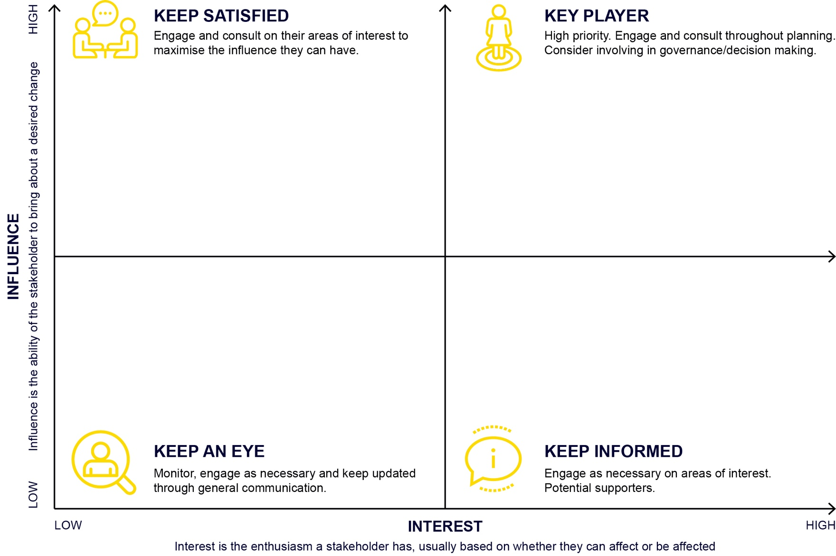
Copy and paste the circles below, type the name of your stakeholder inside and place it on the diagram to the left.

Internal stakeholder

External stakeholder
Insert name
Insert name
Learn more about participation design.

