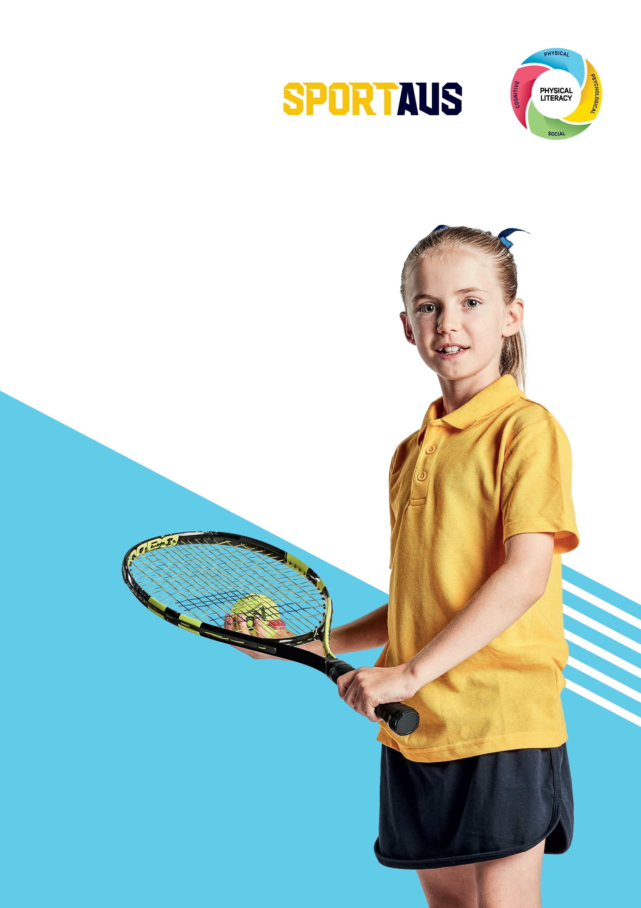
Physical Literacy for SchoolS:
Implementation Plan

Table of contents
Introduction 3
What is physical literacy? 3
What is the Physical Literacy: Guide for Schools? 3
Why undertake this planning process? 4
The planning process 4
1. Gain support from the school leadership 4
2. Establish a working group 5
3. Gather relevant materials 5
4. Run a workshop 5
Understand physical literacy in schools 5
Understand the Physical Literacy: Guide for Schools 6
Create a physical literacy action plan to build a strong physical literacy culture 6
5. Collaborate with the whole school community 7
6. Review and update the action plan 7
Appendix 1: Example action plan 8
Appendix 2: Tips for development 11
Leadership 11
Policy 11
Environment 12
Quality health and physical education program 12
Inclusive co-curricular program 13
Cross-curricular approach 14
Families 14
Local community 15
Appendix 3: Action Plan Templates 16

Introduction
School leaders, educators, coaches and families all play a crucial role in promoting and developing physical literacy in children. The development of physical literacy can be achieved through a whole of school approach that embraces daily play and physical activity. Evidence shows that developing physical literacy improves student:
- mental health and wellbeing
- academic performance
- memory and attention span
- behaviour
- development of life skills
- level of physical activity.

What is physical literacy?
Physical literacy is developing the skills, knowledge and behaviours that give us the confidence and motivation to lead active and healthy lives. It involves holistic lifelong learning through movement and physical activity. It delivers physical, psychological, social and cognitive health and wellbeing benefits. Learn more about physical literacy.

What is the Physical Literacy: Guide for Schools?
The Guide outlines the ideal school environment for optimal development of children’s physical literacy. Using a strengths-based approach, the intent is to build upon what already exists in schools and to help identify opportunities to further strengthen the physical literacy culture. The Guide has three key school areas and eight components. Each component has a number of key characteristics that describes how a school can activate that component.

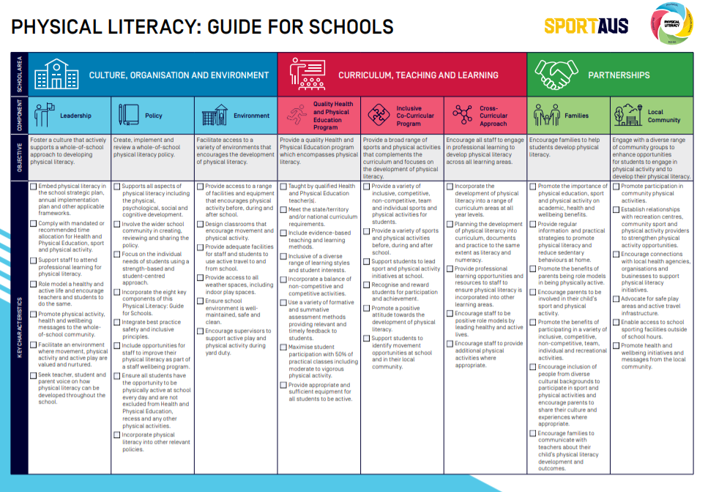

Why undertake this planning process?
Working through this process will help your school to:
- facilitate open communication regarding physical literacy in your school community
- create a shared vision of what physical literacy looks like in your school
- review current practice and identify areas for improvement
- build knowledge and skills of staff to create a strong physical literacy environment
- develop and implement an action plan for continual improvement of a strong physical literacy culture.

The planning process
The planning process is best achieved by including a wide range of people from your school community. This will help create a shared vision on how to embed physical literacy throughout the whole school and ensure the workload is spread accordingly.
Tip: Each school operates in a different environment and has a different capacity to embed physical literacy. Set realistic goals and adapt the process to meet the needs of your school community.
Follow these steps and use the physical literacy action plan templates to review how your school embeds physical literacy and look for opportunities for improvement.

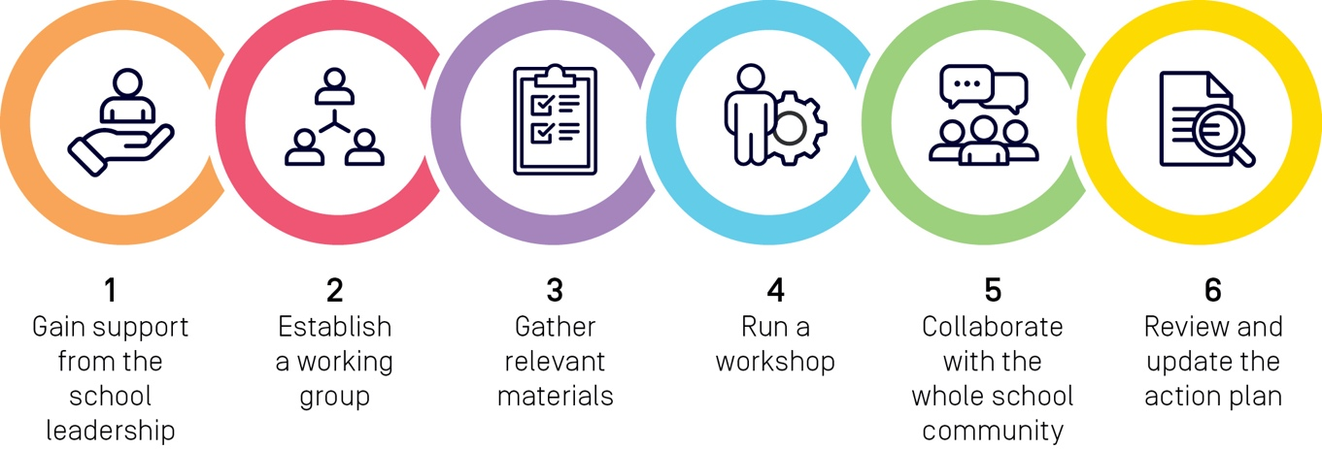

1. Gain support from the school leadership
Educating the school leadership on the benefits of a physical literacy approach is an important first step. Use the Physical Literacy: Benefits for Schools to help explain the student and school benefits of a physical literacy approach.
Ideally, you want the school leadership to:
- understand the benefits of a strong physical literacy culture
- be supportive of applying a physical literacy approach in the school
- agree to implementing the Physical Literacy: Guide for Schools.

Case study: Kalinda Primary School, Victoria
Kalinda Primary School takes a whole of school approach to developing the physical literacy of their student cohort. They are committed to fostering a lifelong love of learning in their students, who are actively engaged in a range of meaningful learning experiences through movement, sport and physical activity. The school leadership are committed to student co-designing initiatives that help develop student physical literacy and use policy to help enable those opportunities.

2. Establish a working group
We recommend you establish a small working group of three to eight people, including a:
- school leader
- Health and Physical Education (HPE) teacher
- generalist teacher
- local sport or physical activity provider
- student leader
- parent
- person not specifically involved in teaching at the school, who can challenge bias and assumptions
- facilitator to guide the workshop.

3. Gather relevant materials
To help the working group understand the context and school environment in which they are working. Read and share these materials with your working group prior to running the workshop:
- Relevant school plans, policies and frameworks
- Physical Literacy: Guide for Schools
- Physical Literacy: Benefits for Schools
- Physical Literacy: Tips for Development (Appendix 2)

4. Run a workshop
Following the below process will assist you to workshop ideas, gain a shared understanding of physical literacy and create an action plan.

Understand physical literacy in schools
- Introduce the concept of physical literacy and watch the video which explains this concept.
- Watch the Kalinda Primary School video to see how physical literacy was embedded in their school.
- Outline and discuss the benefits of physical literacy in schools. Refer to Physical Literacy: Benefits for Schools.
- Identify and discuss how children can develop literacy through a quality HPE program and through other areas of the school environment. Highlight how the whole school working together will have a much greater impact.

Understand the Physical Literacy: Guide for Schools
Take some time to review the Guide and understand the different sections:
- School area – three broad sections of the school where physical literacy can be integrated.
- Components – eight key focus areas within the school environment.
- Objectives – the purpose of each component.
- Key characteristics – actions that a school can undertake to embed physical literacy.
Encourage discussion to better understand the Guide. Questions could include:
- What are your thoughts on the three school areas?
- Are any of the components connected in any way?
- Are there components of the Guide that our school does well?

Create a physical literacy action plan
Break into three small groups to discuss what the school currently does well and identify opportunities to build a stronger physical literature culture. Allocate one of the following school areas to each group and work through the action plan template.
- Culture, organisation and environment
- Curriculum, teaching and learning
- Partnerships.
Tip: Prioritise the key characteristics that will have the most impact for your school. Take a look at the Physical Literacy: Tips for Development for more ideas on how to develop each key characteristic.
Allow time for each group to share their ideas with the larger group. This is a great opportunity to review the ideas and to enhance them, so allow plenty of time for all group members to provide feedback.
Collate action plans into one document and add a cover page and introduction.
Case study: Clare High School, South Australia
With approximately 550 students, Clare High School is known for its commitment to quality HPE, innovative and progressive HPE staff, and a strong school sporting culture. The aim of the HPE program is for students to make informed decisions regarding personal physical activity and wellness choices. The school is well connected to many of the community’s sport and recreation clubs, some of whom use the school facilities. The school also works closely with 14 other schools in the local area.

5. Collaborate with the whole school community
Share the physical literacy action plan across the school community. Start with staff and student representative council. Incorporate their feedback into the action plan before broadening the consultation to include parents and citizens, and local sporting groups. Refine the action plan after each consultation.
Case Study: Vale View State School, Queensland
Whilst Vale View State School is a small school with 80 students grouped into composite classes, it does not impact their ability to prioritise the development of their student’s physical literacy. The school has a strong parent and community involvement, as well as sharing initiatives with other staff in the regional cluster.

6. Review and update the action plan
As a working group, review progress against the plan at regular intervals. Update the plan to reflect the learnings and changing school environment. This will support continuous improvement and creating a strong physical literacy culture in your school. Suggestions include:
- Establish regular review dates and place them in staff calendars.
- Ensure review sessions include:
  - Update the current status of plan
  - Identify further opportunities
  - Celebrate opportunities developed and ensure they are promoted to the whole school community.
- Evaluate progress alongside Annual Implementation Plan and/or strategic plan reviews.

Appendix 1: Example action plan
The example below shows how to use the action plan template, which has been designed to help your school enhance its inclusive co-curricular program. Action plan templates are available to help your school embed each of the eight components of the Physical Literacy: Guide for Schools.

 | INCLUSIVE CO-CURRICULAR PROGRAM
 | Objective | Current status |  |  |  | Opportunities
 | Provide a broad range of sports and physical activities that complements the curriculum and focuses on the development of physical literacy. | What does this currently look like in our school? |  | Priority |  | What can we do to improve this? |  | How do we do this? |  |  | Who will  do it? |  | Who else can help? | Completed by?
Key characteristics | Provide a variety of inclusive, competitive, non-competitive, team and individual sports and physical activities for students. | We offer interschool team-based competitive sports and lunchtime activities are non-competitive fitness and dance sessions. |  | High |  | We don’t have a targeted approach to our co-curricular program. It would be beneficial to match it up to support what is happening in HPE and what students identify as activities students would like to participate in. |  | - Identify how many sports and activities are competitive, non-competitive, team based, individual and identify gaps  - Meet with HPE teachers and identify approaches that are missing  - Survey students and ask what activities they want |  |  | Jason Richardson (teacher) |  | - Sporting Schools partner providers  - SRC could coordinate ideas  - HPE teachers  - Parents who may have local sport and activity contacts  - Local sporting clubs | End term 2
Key characteristics | Provide a variety of sports and physical activities before, during and after school. |  | We offer interschool team-based sports and some of the lunchtime activities include fitness sessions and dance. |  | High |  | Align this key characteristic to the one above and ensure the above balance of opportunities are provided before, during and after school. |  | As above. | Kellie Hanson (HPE teacher) |  | - Sporting Schools partner providers  - SRC could coordinate ideas  - HPE teachers  - Parents who may have local sport and activity contacts  - Local sporting clubs |  | End term 3
 | Support students to lead sport and physical activity initiatives at school. |  | Students are encouraged to support the lunchtime activity program by leading or working with a teacher to support them to deliver a physical activity program. |  | Low |  | Will discuss this in the next review period, as we have some initiatives that address this and other priorities to consider.
 | Recognise and reward students for participation and achievement. |  | We try to monitor student participation and include comments on student reports and celebrate achievements at assemblies. |  | High |  | A more systemised approach is needed to recognise participation as well as achievement. |  | - Ensure students understand the purpose of activities i.e. competition vs participation.  - When rewarding successes in competition, include a sportsmanship award  - Celebrate those activities that are participation based  - Share positive news stories | Kellie Hanson (HPE teacher) |  | Sporting Schools partner providers  HPE teachers |  | End term 3
Key characteristics | Promote a positive attitude towards the development of physical literacy. |  | We try to encourage students to be positive towards their development of physical literacy, but more could be done. |  | Medium |  | Will target this in the next review period, as we have other priorities first. |  |  |  |  |  |  | Next review
 | Support students to identify movement opportunities at school and in their local community. |  | Occasionally in the newsletter we promote physical activity opportunities in the local community, but a lot more could be done. |  | High |  | Support our students in identifying and evaluating physical activity opportunities in their local community. |  | - Discuss this with HPE teachers and identify ways to embed this in the curriculum.  - Work with Sporting School partner providers to find ways to promote local programs.  - Be part of national celebratory days and include local community sporting clubs. | Rani Morales (teacher) |  | - Sporting Schools partner providers  - HPE teachers  - SRC |  | End term 4
Overall rating | 5 = Outstanding - we meet all key characteristics  4 = Excellent – we meet most key characteristics  3 = Good – we meet about half of the key characteristics  2 = Average – we meet some key characteristics  1 = Poor – we don’t yet meet any key characteristics

Appendix 2: Tips for development
This section expands on the Physical Literacy: Guide for Schools, providing more practical examples to help embed each component of physical literacy in your school.

Leadership
- Present information from the Physical Literacy: Benefits for Schools to help school leaders understand the importance of physical literacy.
- Promote and discuss physical literacy initiatives in school leadership team meetings. Provide updates on your Physical Literacy Action Plan.
- Include physical literacy initiatives in your school review and strategic plan.
- Compare the amount of time each year level spends on physical education, sport and physical activity, against mandated state/territory requirements.
- Introduce Australia’s Physical Activity and Sedentary Behaviour Guidelines in a professional learning session and discuss how to increase physical activity for students and staff.
- Engage providers to conduct staff physical literacy professional development.
- Demonstrate a healthy and active life and take part in physical literacy initiatives such as Jump Rope for Heart, lunch time games and sports carnivals.
- Support staff in modelling a healthy and active life and provide stand-up desks, active breaks, stand-up meetings, walking meetings and participation in before and after school physical activity programs.
- Use school surveys to seek parent input on how the school can support their child’s physical literacy development.
- Share trained teachers, sports equipment and temporary play facilities with nearby schools to reduce costs and enhance opportunities.
- Use school newsletter, website and social media channels to promote and share physical literacy initiatives with teachers, parents and students.
- Visit the Clearinghouse for Sport for more information on the role of sport in education.

Policy
- Conduct focus groups and/or surveys with teachers, students, parents and local community providers to help inform the school’s physical literacy policy.
- Incorporate the relevant aspects of the school’s physical literacy policy into the school’s strategic planning cycle.
- Ensure the school physical literacy policy prioritises:
  - a whole school approach
  - development of diverse fundamental movement skills for students
  - environment and social settings that support students develop fundamental movement skills
  - equitable and inclusive practices in health and physical education, sport and physical activities
  - sport and physical activities are flexible, diverse and available to all students.
- Promote the physical literacy policy in the school newsletter and make it available on the school website.
- Get inspiration from the Christ Church Primary School Physical Literacy Policy

Environment
- Create play spaces that are:
  - undercover or shaded to allow for physical activity regardless of weather
  - colourful and eye-catching
  - synthetic to support physical activity for students of all abilities
  - multi-purpose for a variety of sports, games and activities, i.e. set up temporary tennis nets or portable soccer goals on a basketball court
  - creative with loose materials such as car tyres and crates provided. Donations of such objects could be provided by school families and local community members
  - promoted to students and identified on the school map.
- Provide pop-up play spaces to facilitate new play experiences. Encourage students to help identify opportunities.
- Create open spaces in classrooms allowing for movement during group work or cross-circular activities.
- Look for ways the natural environment promotes physical activity. This could include bike paths, walking tracks, large open spaces and outdoor fitness equipment.
- Ensure staff supervise active facilities, such as the gym or sports hall during breaks and provide guidance on how to use the facilities.
- Provide standing desks for students.
- Encourage greater participation, designate areas of the playground to various grade levels and provide equipment sets for each class.
- Seek funding for facilities and resources to support physical activity and sport.
- Ensure facilities are available and supervised before school, during recess/lunchtime and after school.
- Engage the art department and students to create eye-catching messages near active spaces that promote development of physical literacy and physical activity.
- Work with local council and transport authorities to change parking requirements and school drop off zones and create safe walking zones.
- Provide an equipment borrowing program that is managed by the students.

Quality health and physical education program
- Engage Sporting Schools Plus providers and Sporting Schools providers to deliver engaging programs that complement the health and physical education (HPE) curriculum.
- Present information from the Physical Literacy: Benefits for Schools resource in staff meetings and workshops to help teachers understand the importance of physical literacy and discuss how they can help.
- Regularly review the HPE curriculum to ensure the program continually improves.
- Celebrate the importance of the HPE learning area through national and/or state campaigns, such as ACHPER's National HPE Day.
- Analyse student activity/movement time during lessons and across the school day. Apps such as Time Motion can be used to collect data.
- Support students to be active during HPE classes and reward classes who have all students participating.
- Incorporate activities from the Playing for Life activity cards, Yulunga Traditional Indigenous games and Nestle for Healthier Kids school program to support the curriculum.
- Consider how Sport Education could be embedded within the HPE curriculum.

Inclusive co-curricular program
- Engage Sporting School Plus providers and Sporting School providers to provide co-curricular programs.
- Consider which local community sports can help deliver co-curricular programs before, during and after school.
- Recognise and celebrate student participation in co-curricular programs through assemblies, school newsletters and social media.
- Reward students with further opportunities to be active and enjoy movement, such as vouchers to local sporting providers, apparel and equipment stores, or tickets to sporting games and events.
- Encourage staff to contribute to co-curricular programs and provide rewards, such as free gym passes, fitness classes or vouchers for active apparel.
- Use a roster system with the student leadership team to help coordinate physical activity before school, during recess/lunch time and after school.
- Offer year level and school wide physical activity excursions which allow students of different ages to participate together.
- Provide out of school physical activity opportunities that are accessible for all students. This may include bushwalking, surfing, rollerblading, beach volleyball, dancing, ice skating or indoor rock climbing. Also consider fun runs, triathlons, discos, and local community fundraisers.
- Host events where students can explore different activities and find something they enjoy. This may include an amazing race to try different activities or a treasure hunt to discover and explore activities.
- Promote active travel and conduct a walkability audit.
- Consider embedding co-curricular initiatives such as:
  - National Ride2School Day
  - Wakakirri
  - VicHealth’s Walk to School program
  - Safe Cycle
  - iAIM 100km Club Model
  - Your Move
  - Way2Go

Cross-curricular approach

- Engage Sporting School Plus providers and Sporting School providers to help with physical literacy professional learning, classroom energisers and physical activity homework.
- Use information in the Physical Literacy: Benefits for Schools resource to conduct staff professional learning session/s.
- Add a physical literacy planning section in curriculum documentation and templates.
- Share and promote different ways that staff have successfully included physical literacy into their teaching and learning program.
- Leverage health and physical activity awareness campaigns to promote fun movement and physical activities throughout classes.
- Hold outdoor walking classes or standing lessons to break up extended sitting time.
- Encourage health and physical education teachers to create resources and professional learning for classroom teachers on active brain breaks and opportunities for physical activity.
- Ensure teachers provide effective brain breaks.

Families
- Discuss students’ physical literacy development at parent/teacher interviews and include an evaluation on their physical skills and fitness, psychological attitudes and emotions, social interactions, and cognitive understanding.
- Provide tips for parents in the school newsletter and promote information and ideas on developing physical literacy at home.
- Promote the value of physical literacy during school events, information nights and assemblies.
- Allocate a sub-committee of school council to include physical literacy development as a key priority area.
- Ensure a parent or carer is included in your physical literacy working group.
- Provide opportunities for families to give feedback on how to refine physical literacy initiatives throughout the school.
- Seek and support family involvement in coaching sporting teams, active excursions and physical activity sessions before, during and after school.
- Hold a cultural sporting evening where students and their families are invited to play sports that represent their cultural backgrounds.
- Promote sport voucher programs offered in your state or territory, such as:
  - NSW: Active Kids
  - NT: Sport vouchers
  - QLD: Fair Play
  - SA: Sport Vouchers
  - TAS: Ticket to Play
  - WA: KidSport

Local community

- Engage with Sporting Schools providers to connect with local sports coaches/clubs and facilitate out of school opportunities for students.
- Promote local sporting clubs, physical activity providers and recreation centre opportunities to families through school newsletters, daily bulletins, assemblies and social media.
- Develop a directory of local sporting clubs, physical activity providers and recreation facilities and provide regular opportunities for them to connect to programs, conduct before, during and after school programs and participate in assemblies.
- Become a local community hub for physical activity participation and share facilities with local sport and physical activity providers.
- Encourage students who enjoy particular sports and physical activities to make direct contact with the appropriate local provider.
- Select games and sports for your health and physical education program that are played and supported in your local community.
- Invite community sport role models such as well-known athletes and coaches to speak about how they developed their passion for sport and what it means to them.
- Invite representatives from local sporting clubs, physical activity providers and recreation facilities to a morning tea/evening at the school where connections can be formed.
- Encourage shared facility use with local sporting clubs, physical activity providers and/or community groups.
- Work with outside hours school care providers and identify how they can contribute to developing a child’s physical literacy.
- Liaise with local councils and state governments to develop safe play areas and active travel opportunities.
- Establish links with local feeder and partner schools to provide further physical activity initiatives.

Appendix 3: Action Plan Templates
Separate action plan templates for each component of the Physical Literacy: Guide for Schools, so schools can focus on one or more areas for improvement at a time.
 | LEADERSHIP
 | Objective | Current status |  | Opportunities
 | Foster a culture that actively supports a whole school approach to developing physical literacy | What does this currently look like in our school? | Level of Priority | What can we do to improve this? | How do we do this? | Who will do it? | Who else can help? | Completed by?
Key characteristics | Embed physical literacy in the school strategic plan, annual implementation plan and other applicable frameworks.
 | Comply with mandated or recommended time allocation for Health and Physical Education, sport and physical activity.
 | Support staff to attend professional learning for physical literacy
 | Role model healthy and active life and encourage teachers and students to do the same.
 | Promote physical activity, health and wellbeing messages to the whole school community.
 | Facilitate an environment where movement, physical activity and active play are valued and nurtured.
Key characteristics | Seek teacher, student and parent voice on how physical literacy can be developed throughout the school
Overall rating | 5 = Outstanding - we meet all key characteristics  4 = Excellent – we meet most key characteristics  3 = Good – we meet about half of the key characteristics  2 = Average – we meet some key characteristics  1 = Poor – we don’t yet meet any key characteristics

 | POLICY
 | Objective | Current status |  | Opportunities
 | Create, implement and review a whole school physical literacy policy. | What does this currently look like in our school? | Level of Priority | What can we do to improve this? | How do we do this? | Who will do it? | Who else can help? | Completed by?
Key characteristics | Supports all aspects of physical literacy including the physical, psychological, social and cognitive development.
 | Involve the wider school community in creating, reviewing and sharing the policy.
 | Focus on the individual needs of students using a strength-based and student-centred approach.
 | Incorporate the eight key components of this Physical Literacy: Guide for Schools.
 | Integrate best practice safety and inclusive principles.
 | Include opportunities for staff to improve their physical literacy as part of a staff wellbeing program.
 | Ensure all students have the opportunity to be physically active at school every day and are not excluded from Health and Physical Education, recess and any other physical activities.
Key characteristics | Incorporate physical literacy into other relevant policies.
Overall rating | 5 = Outstanding - we meet all key characteristics  4 = Excellent – we meet most key characteristics  3 = Good – we meet about half of the key characteristics  2 = Average – we meet some key characteristics  1 = Poor – we don’t yet meet any key characteristics

 | ENVIRONMENT
 | Objective | Current status |  | Opportunities
 | Facilitate access to a variety of environments that encourages the development of physical literacy. | What does this currently look like in our school? | Level of Priority | What can we do to improve this? | How do we do this? | Who will do it? | Who else can help? | Completed by?
Key characteristics | Provide access to a range of facilities and equipment that encourages physical activity before, during and after school.
 | Design classrooms that encourage movement and physical activity.
 | Provide adequate facilities for staff and students to use active travel to and from school.
 | Provide access to all weather spaces, including indoor play spaces.
 | Ensure school environment is well-maintained, safe and clean.
 | Encourage supervisors to support active play and physical activity during yard duty.
Overall rating | 5 = Outstanding - we meet all key characteristics  4 = Excellent – we meet most key characteristics  3 = Good – we meet about half of the key characteristics  2 = Average – we meet some key characteristics  1 = Poor – we don’t yet meet any key characteristics

 | QUALITY HEALTH AND PHYSICAL EDUCATION PROGRAM
 | Objective | Current status |  | Opportunities
 | Facilitate access to a variety of environments that encourages the development of physical literacy. | What does this currently look like in our school? | Level of Priority | What can we do to improve this? | How do we do this? | Who will do it? | Who else can help? | Completed by?
Key characteristics | Taught by qualified Health and Physical Education teacher(s).
 | Meet the state/territory and/or national curriculum requirements.
 | Include evidence-based teaching and learning methods.
 | Inclusive of a diverse range of learning styles and student interests.
 | Incorporate a balance of non-competitive and competitive activities.
 | Use a variety of formative and summative assessment methods providing relevant and timely feedback to students.
 | Maximise student participation with 50% of practical classes including moderate to vigorous physical activity.
 | Provide appropriate and sufficient equipment for all students to be active.
Overall rating | 5 = Outstanding - we meet all key characteristics  4 = Excellent – we meet most key characteristics  3 = Good – we meet about half of the key characteristics  2 = Average – we meet some key characteristics  1 = Poor – we don’t yet meet any key characteristics

 | INCLUSIVE CO-CURRICULAR PROGRAM
 | Objective | Current status |  | Opportunities
 | Provide a broad range of sports and physical activities that complement the curriculum and focuses on the development of physical literacy. | What does this currently look like in our school? | Level of Priority | What can we do to improve this? | How do we do this? | Who will do it? | Who else can help? | Completed by?
Key characteristics | Provide a variety of inclusive, competitive, non-competitive, team and individual sports and physical activities for students.
 | Provide a variety of sports and physical activities before, during and after school.
 | Support students to lead sport and physical activity initiatives at school.
 | Recognise and reward students for participation and achievement.
 | Promote a positive attitude towards the development of physical literacy.
 | Support students to identify movement opportunities at school and in their local community.
Overall rating | 5 = Outstanding - we meet all key characteristics  4 = Excellent – we meet most key characteristics  3 = Good – we meet about half of the key characteristics  2 = Average – we meet some key characteristics  1 = Poor – we don’t yet meet any key characteristics

 | CROSS-CURRICULAR APPROACH
 | Objective | Current status |  | Opportunities
 | Encourage all staff to engage in professional learning to develop physical literacy across all learning areas. | What does this currently look like in our school? | Level of Priority | What can we do to improve this? | How do we do this? | Who will do it? | Who else can help? | Completed by?
Key characteristics | Incorporate the development of physical literacy into a range of curriculum areas at all year levels.
 | Planning the development of physical literacy into curriculum, documents and practice to the same extent as literacy and numeracy.
 | Provide professional learning opportunities and resources to staff to ensure physical literacy is incorporated into other learning areas.
 | Encourage staff to be positive role models by leading healthy and active lives.
 | Encourage staff to provide additional physical activities where appropriate.
Overall rating | 5 = Outstanding - we meet all key characteristics  4 = Excellent – we meet most key characteristics  3 = Good – we meet about half of the key characteristics  2 = Average – we meet some key characteristics  1 = Poor – we don’t yet meet any key characteristics

 | FAMILIES
 | Objective | Current status |  | Opportunities
 | Encourage families to help students develop physical literacy. | What does this currently look like in our school? | Level of Priority | What can we do to improve this? | How do we do this? | Who will do it? | Who else can help? | Completed by?
Key characteristics | Promote the importance of physical education, sport and physical activity on academic, health and wellbeing benefits.
 | Provide regular information and practical strategies to promote physical literacy and reduce sedentary behaviours at home.
 | Promote the benefits of parents being role models in being physically active.
 | Encourage parents to be involved in their child's sport and physical activity.
 | Promote the benefits of participating in a variety of inclusive, competitive, non-competitive, team, individual and recreational activities.
 | Encourage inclusion of people from diverse cultural backgrounds to participate in sport and physical activities and encourage parents to share their culture and experiences where appropriate.
Key characteristics | Encourage families to communicate with teachers about their child's physical literacy development and outcomes.
Overall rating | 5 = Outstanding - we meet all key characteristics  4 = Excellent – we meet most key characteristics  3 = Good – we meet about half of the key characteristics  2 = Average – we meet some key characteristics  1 = Poor – we don’t yet meet any key characteristics

 | LOCAL COMMUNITY
 | Objective | Current status |  | Opportunities
 | Engage with a diverse range of community groups to enhance opportunities for students to engage in physical activity and to develop their physical literacy. | What does this currently look like in our school? | Level of Priority | What can we do to improve this? | How do we do this? | Who will do it? | Who else can help? | Completed by?
Key characteristics | Promote participation in community physical activities.
 | Establish relationships with recreation centres, community sport and physical activity providers to strengthen physical activity opportunities.
 | Encourage connections with local health agencies, organisations and businesses to support physical literacy initiatives.
 | Advocates for safe play areas and active travel infrastructure
 | Enable access to school sporting facilities outside of school hours.
 | Promote health and wellbeing initiatives and messages from the local community.
Overall rating | 5 = Outstanding - we meet all key characteristics  4 = Excellent – we meet most key characteristics  3 = Good – we meet about half of the key characteristics  2 = Average – we meet some key characteristics  1 = Poor – we don’t yet meet any key characteristics

